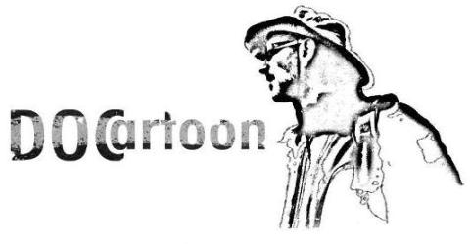

The drawing of reality
il disegno della realtÀ
1° Festival del Documentario Animato
e del Fumetto Non-Fiction
1st Animated Documentary Film
and Non-Fiction Comics Festival

Pietrasanta, 24-30 September 2011

From next September 24 till 30 will take place DOCartoon, the first festival in the world to be primarily dedicated to animated documentaries and non-fiction comics.

Created and directed by Thomas Martinelli, the festival that will develop during the last week of September in the city of Pietrasanta –on the west coast of Tuscany and famous for its artistic vocation- will present a program full of animated documentary screenings and not only, sensitive to current events and reality narrated with the use of creative images. Among the films, quite a few will be European and national previews and premieres. About these more news will be spread towards the end of the month.

Along with the screenings there will be a number of exhibitions related to non-fiction comics set up in the best art galleries in town, including also illustration and painting inspired by reality.

The festival will host also several talks and panels with authors, journalists and intellectuals on current issues and pages of recent history treated by the filmed and drawn works in program. Inaugurations of exhibitions, thematic parties, direct encounters with animators, artists, scriptwriters will be spread throughout the lovely city center in its galleries, bookshops, cafés and public venues.

The logo of DOCartoon was created by Mario Addis.

For further information have a look at the attached press kit and keep an eye for updates on our website (in construction) www.docartoon.it/index_eng.html .

We are obviously open to your requests for explanations you may require.

Hoping in your attention to our new festival, unique in its kind, and to see you soon, we wish you good work and a better summer relax.

Thomas Martinelli, director DOCartoon

thomas.martinelli@katamail.com
www.docartoon.it

